**Installing Python on Windows**

1. **Download Python:**

* Visit the [official Python website](https://www.python.org/downloads/).
* Download the latest version for Windows (usually auto-selected based on your system).

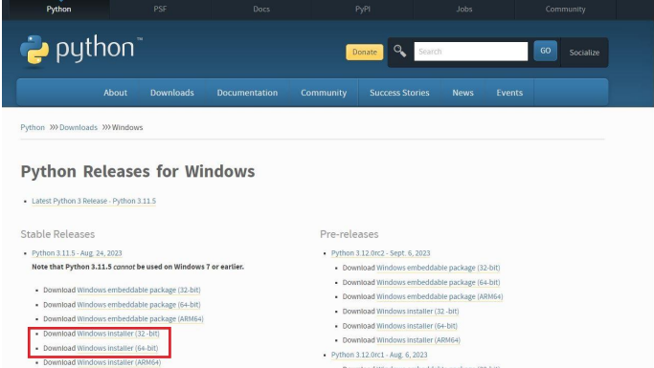

1. **Run the Installer:**

* Double-click the downloaded .exe file to launch the installer.
* **Important:** On the first screen, check the box **"Add Python to PATH"** (this makes Python accessible from the command line).

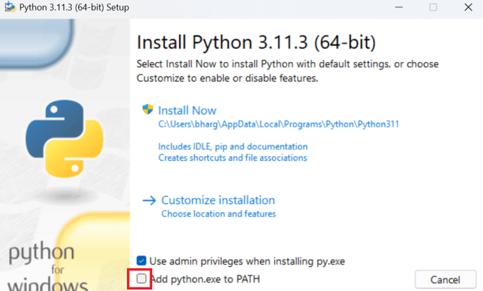

1. **Choose Installation Options:**

* Select "Install Now" for the default setup.
* Or choose "Customize installation" to select specific features, like pip (Python's package manager), or add Python to a custom path.

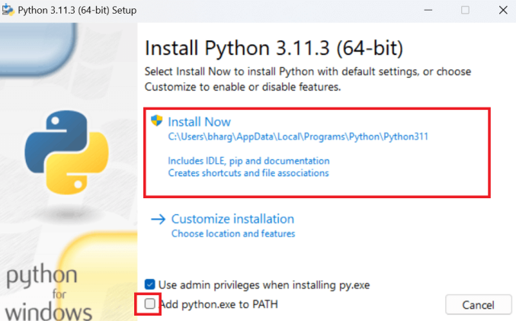

1. **Complete Installation:**

* Click **Install** and wait for the process to complete.
* Once finished, click **Close**.

1. **Verify Installation:**

* Open the Command Prompt (type cmd in the search bar and hit Enter).
* Type python --version or python and hit Enter.
* If Python is installed correctly, you'll see the version number or the interactive Python shell

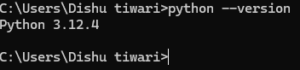

*Basic code

